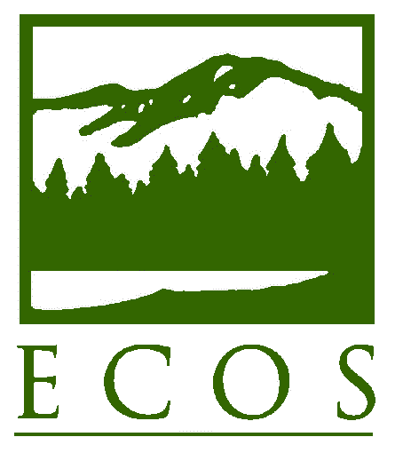

Resolution Number 10-5
Approved August 29, 2010
Whitefield, New Hampshire

Revised September 17, 2013
Arlington, Virginia

Revised September 28, 2016
Wheeling, West Virginia

Revised September 13, 2017
Jackson, Wyoming

Revised October 2,, 2020
Via Conference Call

As certified by
Donald Welsh
Executive Director

IMPROVING COOPERATIVE MANAGEMENT OF PROGRAMS TO
REDUCE NONPOINT SOURCE POLLUTION

WHEREAS, water quality has improved significantly since the passage of the Clean Water Act (CWA) of 1972; and

WHEREAS, the 1987 amendments to the CWA established the Section 319 Nonpoint Source (NPS) Management Program; and

WHEREAS, state environmental agencies are responsible for managing nonpoint source pollution among many other responsibilities to ensure benefits to public health and the environment; and

WHEREAS, water quality has improved as a result of successfully controlling point source discharges through state permit programs; and

WHEREAS, upgrades at wastewater treatment plants to address contributions to impaired water quality from nutrients are reaching a point where in some cases investments to upgrade would result in minimal improvements in water quality, thus highlighting the need for a holistic approach, and major work on NPS permitting has made progress in several parts of the United States; and

WHEREAS, CWA Section 319 provides money to states for programs to reduce pollution from nonpoint sources, with a focus on local partnerships with agricultural entities to reduce water pollution, such as from excessive nitrogen and phosphorous; and

WHEREAS, it is estimated that four dollars in watershed investment is derived from every federal dollar when Section 319 funds are leveraged within U.S. Department of Agriculture (USDA) programs; and

WHEREAS, the USDA, in collaboration with U.S. EPA and state water quality agencies, launched the National Water Quality Initiative (NWQI) in 2012 to reduce nonpoint sources of nutrients, sediment, and pathogens related to agriculture in small high-priority watersheds in each state by accelerating voluntary, private lands conservation investments to improve water quality with dedicated financial assistance; and

WHEREAS, according to the NWQI, agricultural NPS pollution is the leading source of water quality impacts to surveyed rivers and lakes, the third largest source of impairments to surveyed estuaries, and also a major contributor to ground water contamination and wetlands degradation; and

WHEREAS, chloride contamination is an increasing contaminant in key watersheds in the northern United States that will result in long term damage if not effectively addressed; and

WHEREAS, the USDA, in collaboration with U.S. EPA and state water quality agencies, expanded the NWQI in 2018 to reduce nonpoint sources of nutrients and pathogens related to agriculture in small high-priority source water protection watersheds in each state by accelerating voluntary, private lands conservation investments to improve water quality with dedicated financial assistance; and

WHEREAS, U.S. EPA has worked with states and federal agencies to issue a number of administrative reforms to the Section 319 program to ensure grant monies are dispersed more quickly; and

WHEREAS, program reforms include grant guidelines for states and territories that provide updated program direction, an increased emphasis on watershed project implementation in watersheds with impaired waters, and increased accountability measures; and

WHEREAS, in 2005 U.S. EPA began publicly documenting Section 319 success stories about primarily nonpoint source-impaired water bodies where restoration efforts have led to documented water quality improvements and it continues to do so on the U.S. EPA website; and

WHEREAS, reductions in total phosphorus, total nitrogen, and total suspended solids realized from the implementation of Section 319 funded projects over the past twenty years have been tracked by states in EPA’s Grants Reporting and Tracking System, which is the primary tool for management and oversight of EPA's NPS Pollution Control Program; and

WHEREAS, water quality can continue to be substantially improved through agreement on, and successful coordination between, state, federal, and local water quality priorities, nonpoint source control strategies, and financial assistance programs.

NOW, THEREFORE, BE IT RESOLVED THAT THE ENVIRONMENTAL COUNCIL OF THE STATES (ECOS):

Supports increased funding of the CWA Section 319 grants program, so that states can advance progress towards reducing nutrients and other forms of pollution in waters of the U.S.;

Believes the federal government should continue to work collaboratively with states to keep federal programs aligned with state water quality priorities and better focus technical and financial assistance, should support flexibility in national program guidance, and should continue to support, and when appropriate streamline, processes to track program implementation and achievement of water quality, specifically technologies for measuring and addressing urban runoff and advanced measurement techniques to quantify water quality impacts;

Agrees with U.S. EPA that addressing nonpoint sources of pollution is a high priority for the agency and the states, and therefore supports continued collaboration between states and U.S. EPA’s Section 319 program to develop and implement effective nonpoint source pollution control strategies that account for water quality improvements and the protection of high quality waters;

Acknowledges progress made through collaboration of federal agencies, like the U.S. EPA and USDA partnership on NWQI and encourages documentation of how these efforts continue to connect with state water quality priorities;

Advocates for adaptive land use management practices on federal lands that encourage and achieve reductions in nonpoint source pollution;

Supports forward-thinking restoration, protection, and management practices that increase resiliency of watersheds to droughts, wildfires, flooding, or climate change;

Recognizes the beneficial effects and promotes the role of wetlands and riparian ecosystems in reducing nonpoint source pollution;

Encourages continued partnerships among federal agencies including, but not limited to, U.S. EPA, the USDA, U.S. Department of Transportation, U.S. Department of Homeland Security, and the U.S. Department of Interior (including the Bureau of Reclamation and the National Park Service), to create and coordinate effective strategies to reduce nonpoint source pollution in watersheds, and requests that these partners continue to consult with states on their efforts before finalization and implementation to ensure optimal results on the ground;

Encourages the U.S. Geological Survey to continue supporting monitoring and water quality assessment in nonpoint impaired waters in states;

Supports efforts to highlight success within the nonpoint source program and allow flexibility for creative alternative measures beyond the traditional Section 319 success stories by states and federal agencies;

Calls for continued coordination of federal technical and financial assistance to states to implement nonpoint source control strategies; and

Calls for continued evaluation of ways that U.S. EPA and states can work together to streamline the Section 319 grant application and award process to encourage timely awards of annual grant funds to states.

