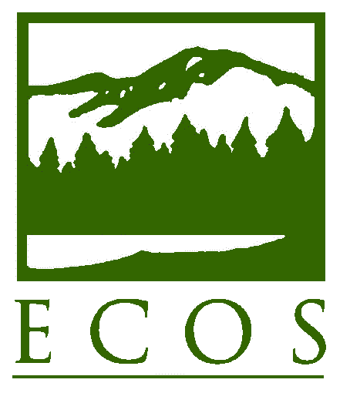
PRESS STATEMENT

FOR IMMEDIATE RELEASE – Wednesday, November 30
Contact: Alexandra Dunn, (202) 230-4247 or adunn@ecos.org
Environmental Council of the States (ECOS)

ECOS Commends U.S. EPA on Drinking Water Action Plan Release

Washington, DC – The Environmental Council of the States (ECOS) welcomes the release today by the U.S. Environmental Protection Agency (EPA) of the Drinking Water Action Plan (Plan). The Plan identifies critical areas in which time, attention, and collective action are needed to ensure that all Americans have access to clean and safe drinking water.

“ECOS commends EPA for moving quickly and thoughtfully to develop this Plan,” said ECOS President John Linc Stine, Commissioner of the Minnesota Pollution Control Agency. “Americans deserve to access their tap water with confidence and to know that their state and federal regulators are vigilant. This Plan sets ambitious but necessary priorities.”

ECOS Water Committee Chair Craig Butler, an ECOS Executive Committee Representative and Director of the Ohio Environmental Protection Agency, added that the Plan “importantly addresses necessary infrastructure investment and accelerates critical reform of the existing lead and copper rule.” Butler noted, “The Plan identifies key areas for a national drinking water conversation, and states look forward to bringing our experience and expertise to the dialogue – particularly as states will be responsible for much of the intensive front-line implementation of the Plan.”

Executive Director and General Counsel of ECOS Alexandra Dapolito Dunn said, “We appreciate the time EPA took to obtain state thoughts on the concepts embedded in the Plan. As we move into the next Administration, this Plan provides a clear roadmap to improve a program that is critical to Americans’ everyday life and to thriving economies.” Dunn referenced ECOS’ Priority Areas for a Time of Political Transition, which discusses the importance of addressing the nation’s serious water infrastructure investment needs and highlights the need for meaningful state-federal collaboration in implementing programs.
ECOS is the national nonprofit, nonpartisan association of state and territorial environmental commissioners. For more information, visit www.ecos.org.

