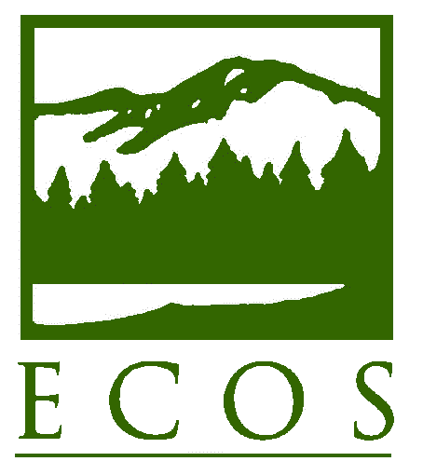
PRESS RELEASE

FOR IMMEDIATE RELEASE – Thursday, July 21, 2016, 8 a.m. Eastern
Contact: Lia Parisien, (202) 266-4931 or lparisien@ecos.org
Environmental Council of the States (ECOS)

Opportunities, Challenges for State-Federal Relationships Cited in Transition Paper

Washington, DC – At its fifth annual State Environmental Protection Meeting at the Mayflower Hotel in Washington, DC, the Environmental Council of the States (ECOS) today released Priority Areas for a Time of Political Transition (Paper). The Paper realizes a key goal in ECOS’ Strategic Plan–reaching out to federal leadership during periods of political transition.

“Through ECOS, state leaders, U.S. EPA, and federal agencies forge collaborative solutions to environmental and public health challenges,” said ECOS President Martha Rudolph, Director of Environmental Programs for the Colorado Department of Public Health and Environment. “ECOS creates the space for stakeholders to come together, offering a respectful atmosphere for dialogue and problem-solving.”

Within this context, the Paper identifies areas of importance for the coming months to maintain—and nurture—sound state-federal relationships and programs, toward the goal of advancing protection of the environment and human health.

- State-Federal Implementation of Environmental Programs: Collaborating for Maximum Results
State and federal agencies must collaborate in the implementation of state-delegated environmental programs. Federal roles should be cooperative and conducted with sensitivity to states’ rights and judgment; federal directives should be thoroughly evaluated to promote flexibility and consider state priorities.

- Advancing a National Conversation on the Nexus between Environment and Public Health
Environmental quality is inextricably linked to public health; keeping this connection front and center allows leaders to focus limited resources on the most important environmental problems—and serves to highlight distracting federal requirements and demands.

- Measuring and Communicating Environmental Results
The success of the state-federal environmental system depends in part on our collective ability to demonstrate how our nation’s investment in environmental protection is delivering tangible results.

- Federal Funding of States: An Integral Part of the U.S. System of Environmental Protection
Federal investment is critical to state implementation of federal environmental programs.

- Addressing Serious Water Infrastructure Investment Needs
Federal collaboration with states to advance innovative funding and technical support for our nation’s aging drinking water and wastewater treatment systems is critical to the U.S. population.

- Advancing Joint Governance through E-Enterprise for the Environment
Joint environmental governance is at the heart of ensuring an effective system of environmental protection, helping us to share information, advance efficiency, utilize technology, and deliver results.

- Discussions around Our Nation’s Energy Future
A national conversation surrounding energy will continue; states have extensive expertise, are demonstrating leadership in this arena, and must be meaningfully included.

ECOS members are available as expert resources, and interviews can be arranged through ECOS Executive Director and General Counsel Alexandra Dapolito Dunn at (202) 266-4929 or adunn@ecos.org.

* * * *
ECOS is the national nonprofit, nonpartisan association of state and territorial environmental commissioners. For more information, visit www.ecos.org.
.

