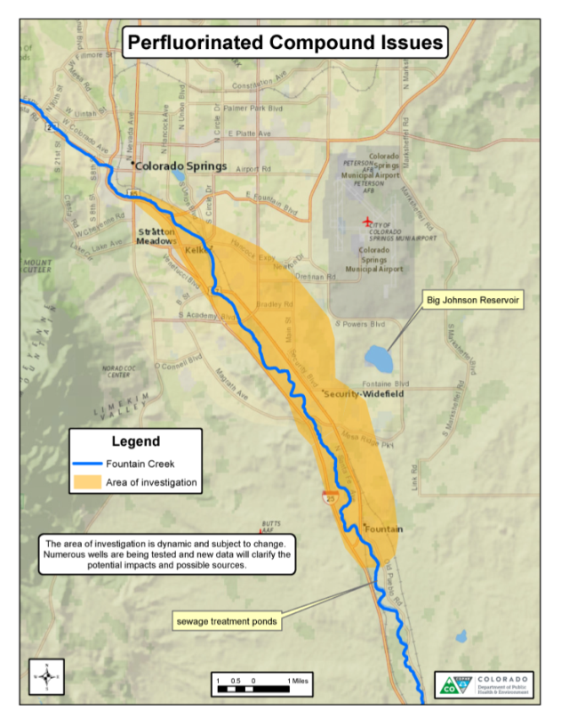
Since January 2016, the department has partnered with the EPA and El Paso County Public Health (EPCPH) to help reduce human exposure to the chemicals from drinking water supplied by wells in the mapped aquifer. February sampling of the three large public water systems – Security, Widefield and Fountain showed PFC levels below EPA’s current provisional health advisory values. Three smaller community water systems also tested their wells and detected PFCs below the health advisory limits. At this time, the level of PFCs in private water wells in the area is unknown.

Currently, PFCs are not a regulated contaminant. However, the EPA established provisional health advisory levels in 2009 for PFOA and PFOS which, if exceeded, suggests the need for discontinuing use of the water for cooking and drinking. CDPHE does not have regulatory authority over unregulated chemicals, any action taken would be based on CDPHE’s broad statutory authority to protect public health.

EPA is updating their health advisory values in April 2016 and they will likely become more stringent. Portions of the Security, Widefield and Fountain could exceed the new values during the high water summer demand season. Possible consequences of this change include:
- All or most of this major water supply aquifer could be taken out of production because water systems may decide to stop using wells that draw from the aquifer.
- It is uncertain if these systems have enough surface water rights to make it through the summer without utilizing impacted wells.
- If a system’s finished water is above the health advisory value, the department would recommend that citizens seek alternative drinking water sources in the impacted areas.
- There could be an increased health concern for residents in the area, especially pregnant women and infants.
- People may become upset because they were previously told that their water was safe. Associated details such as - PFCs are complex chemicals, lack of regulation via the Safe Drinking Water Act, changing health advisory limits will be lost (and are generally confusing).
- If a significant portion of the public is advised to consume bottled water, the economic impact to businesses, restaurants, daycares, schools, health facilities could be severe, and long-term.
- Garnering agreement amongst local public health, EPA and water systems regarding the upcoming changes may prove challenging as there is disagreement amongst some about how information should be shared with the public.

Public Information and Mapping
We continue to build a library of publicly available information. In addition to our PFC webpage with FAQs and resources for the public, we are also working on an interactive map indicating sample locations and data, but done in a way that protects sensitive security and privacy information.

Sampling
The large water systems (Security, Widefield and Fountain) are voluntarily continuing quarterly sampling. EPCPH, in coordination with the department, is working with residents on private well testing. The department is continuing to work with the small public water systems in the area. EPA has agreed to contribute resources including covering limited sampling costs for impacted systems and private water wells.
What are Perfluorinated compounds (PFCs)?
PFCs are a family of human-made chemicals that do not occur naturally in the environment. The compounds can be found in firefighting foams, coating additives, stain and water proofing products such for carpets and clothing.
PFOA = perfluorooctanoic acid
PFOS = perfluorooctanesulfonic acid
PFHxS = Perfluorohexanesulfonic acid

For most people, food and personal care products are the primary sources of exposure and nearly all people have measureable levels of PFCs in their blood.

Source Investigation
The department is working with local water systems, Peterson Air Force Base and the EPA to determine where the PFCs could be coming from. The air force base is currently conducting an investigation to determine if their firefighting activities (and use of PFC-containing foam) could be a source of PFCs in the aquifer.

Risk to Public Health
PFCs are an emerging issue nationally and the health risk information is complicated due to several issues including: 1.) EPA’s ongoing revision of the health advisory values for PFCs,
2.) The lack of health studies on PFCs other than PFOA and PFOS, and
3.) PFCs stay in the human body for many years after exposure. .

Overall, our state of knowledge about the health effects of PFCs is limited. Some human studies have shown that increased exposure to PFCs might increase the risk for some health effects. The most consistent health effects in human studies are increases in blood cholesterol, liver enzymes, and uric acid levels which may be associated with an increased risk of heart disease, liver disease, or high blood pressure. Other studies have shown a correlation – but not a cause and effect relationship – between levels of PFCs in the blood and low birth weight, thyroid disease, some immune system effects, kidney cancer, and testicular cancer.

Background
As part of EPA’s on-going duty to evaluate emerging contaminants of concern, starting in 2013 large public water systems were required to monitor for PFCs. As a result of this national monitoring perfluorinated compounds (PFCs) were identified in 94 U.S. water supply sources including near Security, Widefield and Fountain. These communities are located in El Paso County southeast of Colorado Springs with a combined population of approximately 60,000 people. These three communities are the largest drinking water providers for the area south of Colorado Springs serving customers from both groundwater wells (the Widefield Aquifer) and surface water from Pueblo reservoir via Fountain Valley Authority. Drinking water wells exceeding the current health advisory limits have been shut down or are substantially diluted with other water that does not contain PFCs. Several smaller drinking water systems are also located in this aquifer, as well as private water wells. Initial water samples were collected in 2013 and 2014 as part of an EPA led national, on-going effort to protect water quality. EPA monitors a vast array of potential pollutants to determine if they should be regulated under the Safe Drinking Water Act.

