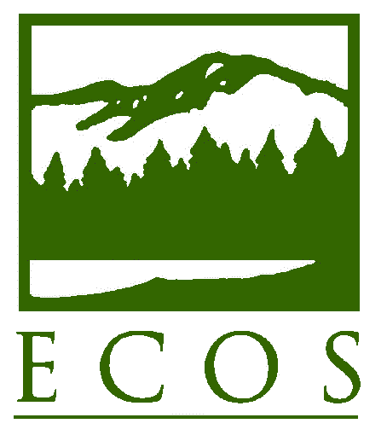
PRESS RELEASE

FOR IMMEDIATE RELEASE –Tuesday, August 18, 2015
Contact: Lia Parisien, (202) 266-4931 or lparisien@ecos.org
Environmental Council of the States (ECOS)
ECOS Launches e-MATRIX to Promote Methane Reduction from Oil and Gas
Washington, DC— ECOS announces the launch of the ECOS Methane and Air Toxics Reduction Information Exchange (e-MATRIX), a database of best practices employed by states and others. Today’s release coincides with the U.S. Environmental Protection Agency (U.S. EPA) proposal to dramatically reduce methane emissions from the oil and gas sector. Eighteen months of discussions by the ECOS Shale Gas Caucus (SGC) culminated in the development of e-MATRIX. Available from this link, the publically available database encompasses dozens of best practices, regulations, protocols, voluntary programs, technologies, reports, and case studies that apply across the natural gas value chain.
“U.S. EPA today announced its intentions with regard to first-time direct limits on methane from energy facilities,” said SGC Co-Chair Dave Glatt, Chief of the Environmental Health Section in the North Dakota Department of Health. “The debut of the e-MATRIX database is indeed very timely, as it will provide useful food for thought for states and stakeholders regarding compliance options.”

Designed to promote interstate and interagency coordination on methane and VOC reduction, e-MATRIX makes available years of research, procedures, and real-life outcomes at the click of a button. A few examples of documents contained in e-MATRIX are:
- Colorado’s pioneering methane and VOC rules designed to reduce emissions by thousands of tons per year;
- Texas’ Leak Detection and Repair (LDAR) program, which provides incentives for voluntary deployment of LDAR and calls for annual leak surveys; and
- North Dakota’s ambitious new rule to reduce flaring, under which the state now requires operators to submit gas capture plans along with all new applications for permits to drill.

SGC project partners that helped make e-MATRIX possible are U.S. EPA, the U.S. Department of Energy, Environmental Defense Fund, Southwestern Energy, and American Gas Association. ECOS also thanks Eastern Research Group for assisting with the development of e-MATRIX. The SGC’s other Co-Chair is Martha Rudolph, Director of Environmental Programs with the Colorado Department of Public Health & Environment and ECOS Vice President.

ECOS is the national nonprofit, nonpartisan association of state and territorial environmental commissioners. For more information, visit www.ecos.org.

