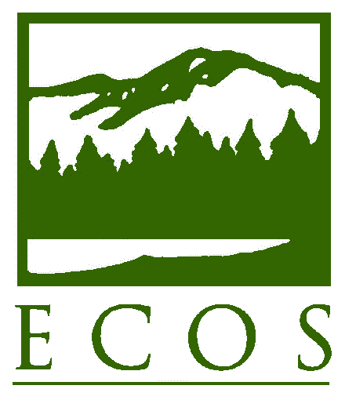
PRESS RELEASE

FOR IMMEDIATE RELEASE – Thursday, April 21, 2016
Contact: Lia Parisien, (202) 266-4931 or lparisien@ecos.org
Environmental Council of the States (ECOS)

Earth Day Offers Chance to Celebrate State Environmental Leadership, Innovation

Washington, DC – This Earth Day, ECOS President Martha E. Rudolph, Director of Environmental Programs with the Colorado Department of Public Health and Environment, reflected on the state contribution to environmental protection nationwide. “Earth Day marks a perfect time to recognize that without dedicated state environmental public servants, our nation would not have the system of environmental protection, information, services, and innovation that Americans deserve,” notes Rudolph.

Nearly every state had an environmental protection authority before the federal environmental laws were enacted, and many federal statutes were modeled in whole or in part on state experience and precedent. Today, states are responsible for overseeing 96 percent of the nation’s environmental enforcement actions and the majority of environmental permitting. “Now more than ever, we are focused on the importance of collaboration among state departments of environment, U.S. EPA, and other federal and state agencies in order to ensure a clean and healthy environment across this country,” Rudolph says.

In the past year, ECOS has advanced a number of innovative efforts. These include:
- An April 11 Memorandum of Agreement (MOA) between ECOS, the Association of State and Territorial Health Officials, and U.S. EPA committing the parties to crafting reports and tools and taking other steps to promote the link between environmental protection and public health;
- Collaboration by ECOS’ Shale Gas Caucus (SGC) at the state and federal levels on cutting-edge and environmentally beneficial uses of produced water;
- Advancement of E-Enterprise for the Environment, a joint state-federal initiative that moves environmental protection into a system of shared responsibility among co-regulators; and
- Coordination with the American College of Environmental Lawyers on a series of educational webinars geared toward improving state environmental agency attorney engagement with nongovernmental organizations and permit applicants.

“These are only a few of the steps that state environmental commissioners are taking through ECOS. We’re sharing our most successful initiatives with one another, thereby helping all state regulators to better serve our constituents and deliver enhanced environmental protection,” says Rudolph. “We continue to face challenges that threaten environmental progress, but our commitment to working together with our federal partners is making a difference – not only on Earth Day but every day.”

* * * *
ECOS is the national nonprofit, nonpartisan association of state and territorial environmental commissioners. For more information, visit www.ecos.org.

