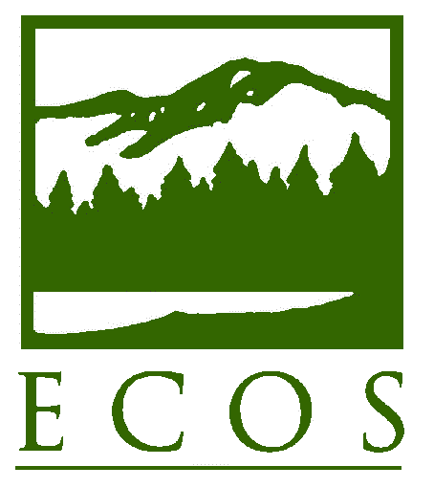
PRESS RELEASE

FOR RELEASE at 1 p.m. – Monday, October 6, 2014
Contact: Alexandra Dunn, (202) 266-4929 or adunn@ecos.org
Environmental Council of the States (ECOS)

Statement on the Appointment of EPA Acting Deputy Administrator Stan Meiburg

Washington, DC –The Environmental Council of the States (ECOS) extends its congratulations to Stan Meiburg on his appointment as Acting Deputy Administrator of the U.S. Environmental Protection Agency. “ECOS is very pleased that President Obama is bringing Stan Meiburg’s decades of experience and knowledge to this important agency role,” said ECOS President Bob Martineau, Commissioner of the Tennessee Department of Environment and Conservation. “Stan’s past work with states as a Regional leader will be extremely valuable as we address new requirements and initiatives, as well as continue the core ongoing work of implementing our nation’s environmental programs with constrained resources,” Martineau added. “We look forward to developing a close working relationship with Stan – who knows the importance of an effective co-regulator partnership between states and the agency – and to finding efficient and thoughtful ways to deliver environmental results to all Americans.”

ECOS is the national nonprofit, nonpartisan association of state and territorial environmental commissioners. For more information see www.ecos.org.

