April 21, 2015

The Honorable Ken Calvert
The Honorable Betty McCollum
House Appropriations Subcommittee on
Interior, Environment, and Related Agencies
United States House of Representatives
Washington, D.C. 20515

Re: FY 16 Appropriations for the U.S. Environmental Protection Agency for Water Programs

Dear Chairman Calvert and Ranking Member McCollum:

We write to thank the Subcommittee for its long-standing fiscal support of the State Revolving Loan Fund (SRF) programs as well as for state clean and safe water programs, and to offer recommendations concerning the Administration’s FY 16 budget request for the U.S. Environmental Protection Agency (EPA) for water programs. Our organizations represent the primary state agencies with responsibility for the programmatic and financial management of the SRF programs as well as administering clean and safe drinking water programs under the Clean Water Act (CWA) and Safe Drinking Water Act (SDWA).

We support, in concept, the Administration’s overall FY 16 budget request for a three-part investment in infrastructure, which includes:

- funding for both State Revolving Loan Funds (SRFs);
- investments to provide technical assistance to small communities; and
- establishment of a new Water Infrastructure Financing Center, as part of the President’s Build America Initiative.

We believe those components, which include a particular focus on water use efficiencies and resilience, will be valuable and necessary elements of an overall program of water infrastructure investments. Below, we provide perspectives and recommendations on each element of the President’s request. We also offer our recommendations for funding of key State and Tribal Assistance Grant (STAG) programs integral to the overall objective of protecting public health and the environment and that work in critical partnership with water infrastructure investments.

In making these recommendations, we acknowledge the fiscal realities facing this nation and the difficult decisions the Committee must make. However, we also highlight our nation’s significant water infrastructure needs. We ask that you give serious consideration to these needs, as described in detail below. This request is consistent with ECOS Resolution 08-1 which urges Congress “to ensure that any authorization of appropriations to fund the SRFs provides an adequate and predictable federal funding stream for water infrastructure now and in the future.” In those instances where our requests are beyond the amounts contained in the President’s budget (i.e., for the CWSRF and for state security programs), we stand ready to work with Congress and the Agency to identify budgetary offsets that do not damage core state and federal programs.

Support for the State Revolving Loan Funds

Record of Accomplishment and Current Needs: The Clean Water State Revolving Loan Fund (CWSRF) and the Drinking Water State Revolving Loan Fund (DWSRF) are among the most successful and cost effective environmental programs enacted by Congress. The funding assistance provided to both small and large communities through this Federal-state partnership has achieved a remarkable record and been instrumental in delivering safe and clean water for the American public. The “revolving” nature of the loan programs and states’ efforts to maximize Federal capitalization grants assure a continuing, exponential return on Federal investments. This successful history, however, is paralleled by a growing national water and wastewater infrastructure need. Cities and towns across the country face aging and decaying water and wastewater systems sorely in need of the types of investments advocated below.

Support for the DWSRF: We support the Administration’s FY16 request of $1.186 billion for the DWSRF. In view of the American Society of Civil Engineers’ “grade” of D+ for our nation’s drinking water infrastructure and the most recent EPA drinking water infrastructure “needs” estimate of $384 billion over the next 20 years, this modest increase over the previous year’s funding is certainly warranted. A recent spate of unfortunate events, over the past year, resulting in contaminated drinking water in a number of locations across the country, have only served to underscore the criticality of drinking water infrastructure – as well as the associated “human infrastructure” at both the state and local levels.

Support for the CWSRF: Clean water infrastructure likewise has a 20 year national estimated need of $298 billion according to the EPA. 2008 Clean Watersheds Needs Survey – comparable to the drinking water need mentioned above. In light of those pressing needs, we are concerned with the FY16 budget request of $1.116 billion for the CWSRF program. This reduction from the FY15 enacted level of $1.449 billion is at odds with the demonstrated need and high cost of wastewater projects. We thus urge the Subcommittee to fund the CWSRF at the FY15 enacted level.

Administration’s Proposed CWSRF Program Revisions: The President’s budget recommends that not less than 20% of SRF capitalization grants be used to promote green infrastructure or environmentally innovative projects that promote water system and community resilience. While we are supportive of incorporating green infrastructure and environmentally innovative approaches into CWSRF funded projects when practicable, we are concerned with this recommendation because it, in effect, forces states to fund lower priority projects to meet threshold requirements rather than focusing on higher priority projects with the greatest need. States would prefer to have greater discretion in determining how funds can be used. The CWA amendments enacted in 2014 as a part of the Water Resources Reform and Development Act (WRRDA) addressed these same issues, and states are in the process of incorporating these new statutory provisions and responding to the new requirements. It is disruptive for states to face further change in these areas until there is a demonstrated need for further alteration.

Water Infrastructure Investments to Help Small Communities and Assist States

The Administration has requested $39.3 million in support for water infrastructure investments that would support providing technical assistance designed to help small communities is designing effective pricing structures, incorporating best practices, developing integrated plans, and undertaking climate resiliency planning. We support that request and states stand ready to assist in these various efforts. Small communities, with poorer economies of scale and often less access to needed expertise can greatly benefit from the type of assistance envisioned. In short, we believe the planned areas of focus are appropriate and much needed.

EPA’s Water Infrastructure & Resilience Finance Center & WIFIA Program Establishment

The President’s budget requests $7.1 million and 12 FTEs to “stand up” a new Water Infrastructure and Resilience Finance Center in order to expand work on identifying financing opportunities for small communities and to promote public-private partnerships for water infrastructure. A center of excellence as envisioned in this budget request could be of real long-term benefit to water and wastewater infrastructure community. The President also requested $5 million to establish a pilot program called for by the Water Infrastructure Financing Innovations Act (WIFIA) under WRRDA. The Administration has not requested any WIFIA-related funding in the FY 16 budget cycle beyond that recommended for EPA’s administrative expenses to design and develop a WIFIA program structure and we support that approach. .

State and Tribal Assistance Grants (STAG)

Finally, we offer specific recommendations relative to these critical grants to states. These below programs fund essential personnel – including engineers, permit writers, inspectors, biologists, and compliance assistance officials – who play critical roles in helping ensure clean and safe water for all Americans. Our recommendations on each grant program are as follows.

CWA §106 Program: We support the Administration’s request of $249 million for state pollution control programs under CWA §106. This funding is essential for states to implement a wide array of ongoing water pollution control programs, such as the National Pollutant Discharge Elimination System (NPDES) program.

CWA §319 Program: The CWA §319 program is unique for its focus on local partnerships with agricultural entities to reduce water pollution, such as excessive levels of nitrogen and phosphorus. We estimate that four dollars in watershed investment is derived from every federal dollar when §319 funds are leveraged with U.S. Department of Agriculture programs. Similar partnerships for other pollutants also leverage multiple funding sources to protect and restore watersheds. We urge the Subcommittee to fund the President’s request of $164.9 million, although the national need is significantly greater.

CWA Wetland Program Development Grants: We support the Administration’s request for $19.7 million to assist state wetland program development. This funding is critical to states and supports improvements in state wetland programs based on priorities identified by individual states. States can apply for support for a wide range of activities such as monitoring wetlands health, developing water quality standards for wetlands, improving permitting programs and enhancing voluntary wetland restoration programs.

SDWA PWSS Grant: The President’s request for the Public Water System Supervision Program (PWSS) was $109.7 million. While we appreciate this modest increase of approximately $5 million over the FY 15 enacted level, we believe the amount is still well short of what is needed for this critical work on the part of states to implement SDWA programs in their states. Further, we believe a small, but much needed grant of $10 million for state drinking water security programs is needed to allow states to continue to be the critical nexus between Federal and local efforts to promote preparedness and resiliency in the face of “all hazards” threats to drinking water.

Support for Integrated Planning: Finally, while not a STAG program request per se, we offer the following recommendations relative to a policy that ties closely to states’ work under their 106 grant programs. The integrated planning approach, as authorized by a recent EPA policy (“Achieving Water Quality through Integrated Municipal Stormwater and Wastewater Plans Integrated Planning Framework”) provides communities with greater control over the pace and sequencing of water quality improvements, promotes innovative solutions such as green infrastructure, and maximizes limited resources. States appreciated the Agency’s May 2014 announcement of the availability of $335,000 in technical assistance for up to five communities to develop and implement an integrated plan. We encourage the Subcommittee to support the President’s request of $13 million to EPA to expand the technical assistance program so that more practical examples of how to implement the different steps in developing an integrated plan.

In summary, we urge your continued support for the SRF programs as well as state clean and safe water programs and appreciate the opportunity to share our views as the Subcommittee undertakes its work on the FY 16 appropriations bill. Sincerely,
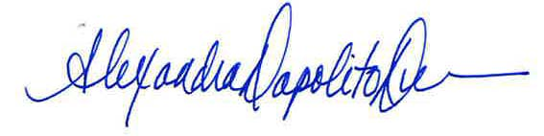
Alexandra Dunn
Executive Director
Environmental Council of the States
Julia Anastasio
Executive Director
Association of Clean Water Administrators
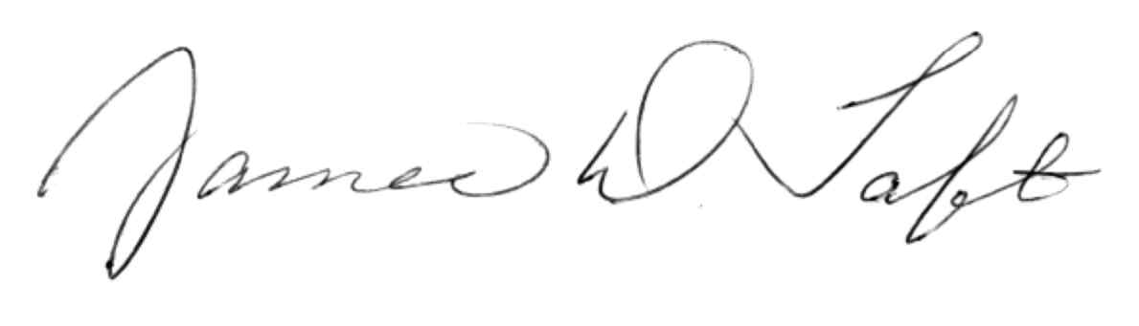

James Taft
Executive Director
Association of State Drinking Water Administrators 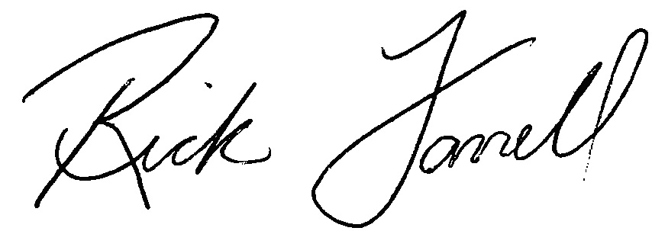
Rick Farrell
Executive Director
Council on Infrastructure Financing Authorities

Jeanne Christie
Executive Director Association of State Wetland Managers

