
Copyright © 2013, the Environmental Council of the States. Permission is granted for our members to copy for state government purposes.

2013 STATE INNOVATIONS:
AGENCIES ENHANCE OPERATIONS AND OUTREACH
December 2013
By Lia Parisien, Executive Project Manager, Layne Piper, Staff and Research Assistant,
and Becca Merrifield, Research Intern, Environmental Council of the States

INTRODUCTION

For more than a decade, ECOS has asked its members to share information on innovative programs so that other states might learn from their colleagues’ example. State-developed initiatives are solving pressing challenges, both in protecting human health and the environment and in enhancing operations within agencies themselves. From incorporating new technologies in data tracking and permitting to enhancing communication with the public to promoting sustainability, states truly are at the cutting edge.

ECOS launched the State Program Innovations Awards six years ago to recognize innovations of interest to other members. This year ECOS was pleased to receive a dozen impressive nominations. In September, the association provided special recognition at its Annual Meeting in Crystal City, Virginia to the three winners selected by the ECOS Executive Committee.

Through its ePermitting System, the Missouri Department of Natural Resources has streamlined the application process for stormwater construction permits, yielding significant time savings for applicants and staff alike and freeing up staff to pursue other environmental protection activities. Meanwhile, a new public hearing model implemented by the Oregon Department of Environmental Quality has bolstered participation and transparency for high-stakes public hearings. In another public outreach advance, the Indiana Department of Environmental Management has implemented the Institutional Controls Registry using a website of data and mapping tools to better protect human health by providing timely data about remediation sites.

These innovation awardees and several other nominees are profiled below. ECOS hopes that the information in this report will encourage its members to adopt, adapt, or collaborate on these initiatives. The association looks forward to continuing the tradition of forward-thinking innovation in 2014.

TABLE OF CONTENTS

Winner’s Circle 3
Missouri’s ePermitting System – Stormwater Construction Permits 3
Oregon’s Public Hearing Communications Model 4
Indiana’s Institutional Controls Registry 5
Agency Improvement Innovations 7
Maine’s New Sustainability Division 7
Air Innovations 8
Oregon’s Greenhouse Gas Inventory 8
Information Management Innovations 10
Indiana’s Combined Sewer Overflow Tracking Project 10
Permitting Innovations 17
South Carolina’s Permit Central 17
Pennsylvania’s Permit Review Process and Permit Decision Guarantee 18
Waste Innovations 19
Wisconsin’s Initiative for Sustainable Remediation and Redevelopment 19
Massachusetts’ Diversion of Organic Material from Disposal to Clean Energy and Other Beneficial Uses 21
Water Innovations 23
Iowa’s Point Source Nutrient Reduction Strategy 23
Virginia’s Wetland Condition Assessment Tool 24

WINNER’S CIRCLE

Missouri’s ePermitting System – Stormwater Construction Permits

Description of Initiative:

EPermitting is Missouri’s customized online web application that allows citizens to apply, pay for, and receive general stormwater construction permits from the Missouri Department of Natural Resources (MDNR). General stormwater construction permits are the most common permit issued by the MDNR; in some years more than 1,500 have been issued. Applications for these permits were formerly sent to five regional MDNR offices where they were processed manually using procedures unique to each office. Manual processing included verifying application completeness, processing the application fee, data entry into multiple databases, and manually typing each permit. Permit processing also included the crucial step of identifying the watersheds and water bodies potentially impacted by the construction activity. This manual process typically took several days to a few weeks. Because this is the most common permit issued by the MDNR, and because applicants had to wait to commence construction until the permit was completed, the MDNR sought more efficient ways to issue these permits.

The new ePermitting system allows citizens to obtain a valid stormwater construction general permit from the comfort of their home or office in a matter of minutes. It guides users through the application process, including an interactive GIS tool that allows applicants to draw a polygon representing the construction area on a customized map. The system processes the application fee and issues the final permit. Users can immediately print their permit and supporting materials, including a map of their construction area. ePermitting also directly interfaces with the MDNR’s fees and NPDES databases, eliminating the need for manual and duplicative data entry.

The most unique feature of ePermitting is its interactive GIS component. User-friendly tools enable applicants to draw the area of land disturbance on a map. The built-in GIS application calculates the acreage that will be disturbed, determines the receiving stream and classified waterbodies downstream of the construction activity, and identifies the beneficial uses of those waterbodies. All of this occurs within a matter of minutes.

Results to Date:

After a two month phase-in beginning in June 2012, the MDNR now requires all applicants to use ePermitting to obtain general stormwater construction permits. Between June 2012 and May 2013, 854 permits were issued through ePermitting. Based on feedback from applicants, the average time from initial log on to the system to printing a permit was less than one hour. Based on an average of 6 days per application under the old process, this translates to a significant time savings for MDNR’s applicants. MDNR staff time savings is also significant, allowing the MDNR to direct staff to activities more beneficial to human health and the environment. Redirection of staff away from paper processing to more field work, inspections, and compliance assistance has yielded beneficial environmental results.

Contact:

Kimberly Hoke
IT Policy Director
Missouri Department of Natural Resources
kimberly.hoke@dnr.mo.gov
(573) 751-6621

Oregon’s Public Hearing Communications Model

Description of Initiative:

Public involvement and transparency are key elements of government. Creating opportunities for meaningful involvement in controversial permits or rulemakings can be challenging. With public hearings for a controversial coal export facility on the horizon, the Oregon Department of Environmental Quality (DEQ) determined that the agency needed a new model for public hearings with high public interest.

Business, citizens, local governments, and environmental groups are deeply invested in the outcome of this permitting process. Late last year DEQ held three four-hour evening information meetings attended by crowds up to 800. They noted participants’ frustration over waiting all evening and not having the opportunity to speak. DEQ decided to take a different approach for upcoming public hearings on the permits, determined to provide better opportunities for people to participate. The result was a model with multiple ways for citizens and stakeholders to participate during DEQ’s public hearing process and a new level of real-time transparency.

DEQ designed a new public hearing model and leveraged existing software, databases, and free third-party services to create a cost-effective integrated, online public hearing experience.

Elements of this communication model:

- Online public informational meeting—This gave people the opportunity to review information at their own pace, 24/7. Online slideshows that clearly outlined the permits that were open for public comment using PowerPoint web apps and Microsoft SkyDrive provide a smooth and efficient user experience.
- Web based comment form—DEQ gives the same weight to written and verbal comment. The goal was to make it easy for citizens to comment online and attach additional documents if desired. The agency created an online comment form and added the extra functionality of displaying comments in real-time on the web page. This created a new level of transparency and gives citizens the ability to see what other comments have been made in real-time.
- Online registration to give public comment in person—Normally citizens may have to spend hours waiting to give comment at high-profile public hearings. For example, during three informational meetings for permits related to the Coyote Island Terminal—a coal export facility—144 comments were received during three separate meetings with a combined attendance of over 1,200 people. Attendees waited for hours, and due to time constraints only a small number were able to give comment. Various advocates disrupted the proceedings and interrupted speakers, many of whom confided that they felt intimidated.
By comparison, public comment hearings used a third-party registration system. The meeting structure filled one day, starting at 8 a.m. and ending at 8 p.m. Sessions were broken into two-hour time periods with 30 available registration slots plus a limited number of walk-ins. These sessions were set up in two locations using three rooms. In one day, this provided 540 open slots for public comment. In addition, citizens were assigned a two-hour window to give their comment. This structure created more opportunity for DEQ to receive comments and respect commenters’ time, and provided a more orderly and less intimidating environment for commenters.

Results to Date:

More than 500 people attended the hearings, and 350 provided in-person comment. The proceedings were calm and orderly, and many individuals thanked DEQ staff for the new approach. Based on a public engagement survey distributed at the meetings, 65 percent of hearing participants agreed that DEQ provided opportunities for them to weigh in on issues, compared with about 45 percent for the informational meetings.

While groups rallied outside the facility, there were no disruptions in the hearing rooms even though many people brought a great deal of passion to their testimony. News releases directed more than 3,000 visitors to the website, and to date, 259 people have commented online.

Contact:

Joanie Stevens-Schwenger
Outreach and Communications Manager
Oregon Department of Environmental Quality
(503) 229-6585 (office)
(971) 563-6662 (cell)

Indiana’s Institutional Controls Registry
Description of Initiative:
The Indiana Department of Environmental Management (IDEM) Institutional Controls (IC) Registry is a management system used to track sites with land use controls due to the presence of residual contamination, and to provide notice to local government units, the regulated community, developers, and other interested stakeholders of important site information in order to protect human health. The registry includes sites in all of the Indiana remediation programs including voluntary remediation, leaking underground storage tanks, brownfields, state cleanup, federal programs, RCRA corrective action, and certain solid waste disposal sites. The IC Registry is a publicly accessible, web-based site that uses three interface tools to provide information about sites subject to ICs.
A Microsoft Access database provides the foundation of the registry, with fields to track related information (address, site-specific restrictions, contaminant type, etc.) A subset of this information is provided publically via a PDF format file entitled the “IC Registry Remediation Sites Report” on the IDEM website (http://www.in.gov/idem/5959.htm ). A separate summary report listing solid waste sites with deed notices is available at the same web address.
The second interface tool, a comprehensive statewide GIS mapping platform called the IndianaMAP (http://indianamap.org), contains an IC GIS layer. This layer is viewable by going directly to the IndianaMAP website or by using the “view” hyperlink on the “IC Registry Remediation Sites Report”. The IC GIS data layer shows the location of each IC property either through a single point feature or a GIS polygon (created with ArcInfo coordinate geometry [COGO] software). Indiana is one of the first states to use polygons to portray the actual areal extent of restricted areas.
Finally, the IC Registry is integrated with records residing in the Virtual File Cabinet (VFC), Indiana’s web-based document repository. Hyperlinks on the “IC Registry Remediation Sites Report” allow users to open and view each original IC for the site (e.g. restrictive covenant, deed notice).
IDEM staff continue to improve IC Registry functionality with ongoing initiatives including:
1) replacement of original single point GIS features with newly created COGO GIS polygons as staff resources allow; 2) input of solid waste sites with deed notices (with depiction of waste boundaries), and 3) co-development of a standard IC flow schema for the Exchange Network that may be used for future data sharing initiatives at: (http://www.exchangenetwork.net/data-exchange/ic/) .

Results to Date:

- More than 1,160 remediation sites, and over 40 solid waste sites, entered in the IC registry
- Integration with VFC and state-based GIS map for public accessibility
- Creation of GIS polygons for over 300 sites using COGO software
- Improvement in geospatial accuracy for ICs; prior to initiating COGO quality assurance checks there was an approximate 10 percent error rate in submitted geospatial data or legal descriptions
Contact:
Nancy Dollar
Technical Environmental Specialist
Indiana Department of Environmental Management
ndollar@idem.IN.gov
(317) 234-4814

AGENCY IMPROVEMENT INNOVATIONS

Maine’s New Sustainability Division

Description of Initiative:

In August 2012, the Maine Department of Environmental Protection created a new division to undertake a cross-media and multi-program approach to material management. Including merging disparate recycling programs and management responsibilities, the goal of this innovative new division is to create a team which oversees the implementation of a comprehensive, coordinated, and holistic approach to materials management.

Specifically, the Sustainability Division has responsibility for:

- Administering the various product stewardship programs overseen by the department. These programs include: electronic wastes; cell phones; mercury thermostats; mercury-added (fluorescent) lamps; mercury auto switches; dry cell mercuric oxide and rechargeable batteries; and unwanted paint (effective 2015);
- Furnishing technical assistance to residents, municipalities, institutions and businesses on waste reduction, reuse, recycling and composting opportunities. Currently, a major emphasis is being placed on diverting unwanted organics from disposal, with those organics sent for use as animal feed or to composting operations or for anaerobic digestion;
- Directing the chemical management programs which include the priority chemicals in products program and the toxic chemical reduction program;
- Encouraging the restaurant, lodging, and grocery sectors to participate in and become recognized for their sustainability activities through the recently rebranded Environmental Leader Program; and
- Being the department’s resource for greenhouse gas and climate change/climate adaptation issues, with a focus on Maine’s strategy for addressing potential impacts.

Results to Date:

A number of the highlights of the recently created Sustainability Division include:
- Aiding several municipalities and institutions, including medical facilities, in designing and implementing organic waste composting programs;
- Implementing revisions to the priority chemical law, including the creation of the list of chemicals of high concern, and the sales prohibition on infant formula and baby food packaging containing intentionally added- Biphenyl A, effective March 1, 2014;
- Assisting the state’s largest anaerobic digestion operation in identifying and securing organic waste;
- Outreach on adaptation and related challenges and opportunities surrounding severe weather incidents;
- Expanding outreach to municipalities and businesses on recovery and recycling of fluorescent bulbs, mercury thermostats, and other Universal Waste;
- Preparing the 2011 Waste Generation and Disposal Capacity Report and presenting it to the Governor and the Legislature in early 2013;
- Beginning work on the update to the state’s five-year Waste Management & Recycling Plan;
- Certifying or recertifying more than 35 businesses in the Environmental Leader program; and
- Initiating the toxic use reduction reporting requirements and outreach to regulated entities.

Contact:

George M. MacDonald
Director of Sustainability Division
Maine Department of Environmental Protection
george.macdonald@maine.gov
(207) 287-2870 (desk)

AIR INNOVATIONS

Oregon’s Greenhouse Gas Inventory

Description of Initiative:

Oregon has pioneered a new and more comprehensive approach to assessing greenhouse gas emissions in order to better identify opportunities for, and track progress toward, reducing the state’s contribution to global greenhouse gas emissions. This new approach addresses gaps in traditional methods of state emissions accounting to help inform policy decisions. In 2007, Oregon’s Legislature adopted greenhouse gas reduction goals: to arrest growth and begin to reduce emissions by 2010, and to reach a 10 percent reduction below 1990 levels by 2020 and a 75 percent reduction from 1990 levels by 2050. To assess whether the state had met this first goal, Oregon agencies (Environmental Quality, Energy and Transportation) collaborated to prepare a comprehensive and multi-faceted inventory of emissions that expands upon traditional approaches to include worldwide emissions associated with Oregonians’ consumption, and a broad estimate of emissions associated with travel by Oregonians and freight serving Oregon’s economy.

Results to Date:

Key findings from Oregon’s greenhouse gas inventory report, Oregon’s Greenhouse Gas Emissions Through 2010: In-Boundary, Consumption-Based and Expanded Transportation Sector Inventories, include:

- Though emissions from the transportation sector remain the largest source of in-state emissions, the residential/commercial sector has become a nearly equal part of the traditional inventory.
- More than half of the emissions in the consumption-based inventory occur in other states and countries in order to make goods and services that Oregon imports for consumption.
- Freight and air travel are a growing part of Oregonians’ transportation emissions, as emissions from these travel segment have increased while emissions from passenger vehicles have recently begun to decline.

The recently published inventory of Oregon’s greenhouse gas emissions represents the next step in the evolution of greenhouse gas accounting in Oregon by including two important changes to inventories performed in previous years.

First, the accuracy of the traditional inventory of emissions within Oregon was improved by transitioning from an entirely "top down" modeling estimate to a primarily "bottom up" aggregation of data reported by the emission sources themselves. These reported emissions are derived from actual fuel volumes and electricity supplied in Oregon reported by the state’s fuel suppliers and electric utilities, and emissions calculated by the state’s largest industrial emitters.

Second, the report evaluates emissions through three different lenses: 1) the aforementioned inventory of emissions from in-state sources and electricity usage, 2) worldwide emissions associated with satisfying Oregonians’ consumption, and 3) an expanded examination of emissions from the transportation sector. To our knowledge, Oregon is the first state to include in its emissions inventory an estimate of global emissions resulting from local consumption, and to publish a greenhouse gas inventory report using more than one accounting approach. This innovation is important because no single inventory tells the full story of how Oregon contributes to global greenhouse gas emissions, and none is necessarily the "right" method for all contexts.

Ultimately, greenhouse gas inventories are intended to inform actions to reduce our contribution to greenhouse gas emissions. All three inventories help identify emission reduction opportunities for Oregon residents, businesses, government agencies, and policymakers. Multiple perspectives provide a more comprehensive understanding of how Oregon contributes to emissions, which gives us a broader range of ideas for how we can reduce these emissions.

Including out-of-state emissions alongside emissions from in-state sources has helped address criticism that state environmental policies may unfairly penalize in-state businesses by counting their emissions while ignoring the impacts of foreign competition. The greater breadth of sources and activities evaluated by the multiple inventories has been used to inform a variety of recent state climate planning, including the Oregon Global Warming Commission’s Interim Roadmap to 2020, the Governor’s 10 year Energy Action Plan, the Oregon Transportation Commission’s Statewide Transportation Strategy, and the Oregon Environmental Quality Commission’s Materials Management 2050 Vision and Framework for Action.

Contact:

Andy Ginsburg
Air Quality Administrator
Oregon Department of Environmental Quality
(503) 229-5397 (office)
(503) 572-7195 (mobile)

INFORMATION MANAGEMENT INNOVATIONS

Indiana’s Combined Sewer Overflow Tracking Project

Description of Initiative:

The Combined Sewer Overflow (CSO) group of the Indiana Department of Environmental Management (IDEM)/Office of Water Quality (OWQ)/Permits Branch developed a database module to track Long Term Control Plan (LTCP) milestones, internal IDEM milestones, compliance reviews, information related to CSO outfalls, and general information related to each CSO community.

This database is in “TEMPO” – Tools for Environmental Management and Protection Organizations. TEMPO is a software application created by CGI Technology and Solutions Inc., which has been customized by IDEM to meet the needs of the CSO group.

Information logged in the CSO TEMPO Database follows:

- LTCP CSO tasks that must be completed by each community to meet the requirements of the LTCP are entered into the database and can be tracked. These “tasks” include the LTCP implementation tasks, LTCP approval/completion dates, and various other milestone dates. Each task has a description of what activity must be completed by the permittee as well as the required start date and due date. The completion date for the tasks will be entered by IDEM staff when the communities provide notification that each task is finished.
- General information related to each CSO community that frequently needs to be searched, such as the type of enforceable document through which the LTCP schedule is enforced (i.e., agreed order, state judicial agreement, or federal consent decree), NPDES permit number, associated Virtual File Cabinet (VFC) document number, LTCP design goals, and major/minor facility designation.
- CSO outfall information for each CSO community, including receiving stream, basin, sub-basin, watershed, county, latitude/longitude, active/inactive status, treated/untreated status, etc.
- Compliance reviews completed by the CSO staff. These reviews include audits and compliance reviews of fully implemented LTCPs to ensure they achieve their design goals.

Results to Date:

Various reports can be generated using the information that has been entered into the database.
The current reports include:

- Compliance Status Report: This report can be used to report the Compliance Status for CSO communities. The report can account for both types of compliance reviews and can be manipulated to provide data for various date ranges and other screening criteria. The report example below is a Compliance Status Report for all compliance reviews completed in 2012.

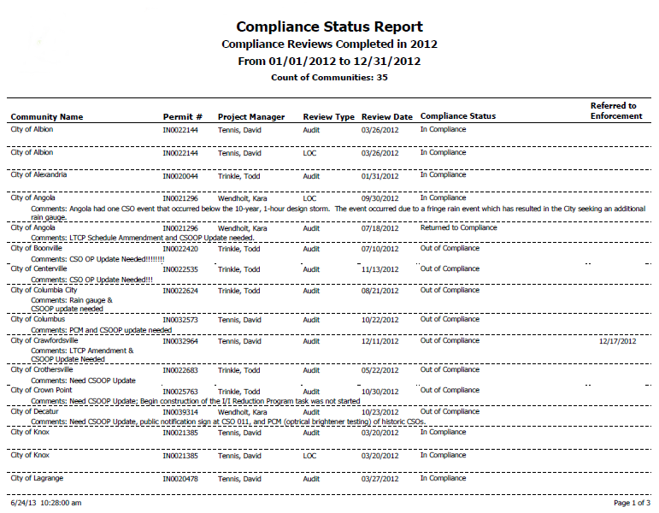

- Document Attributes Report: This report can retrieve a list of facilities by enforceable document (agreed order, state judicial agreement, federal consent decree), or can search LTCP design goals, associated VFC document numbers, or NPDES permit numbers. This report has the ability to accommodate other general information as the program moves forward. The example report below shows all agreed orders related to LTCPs.

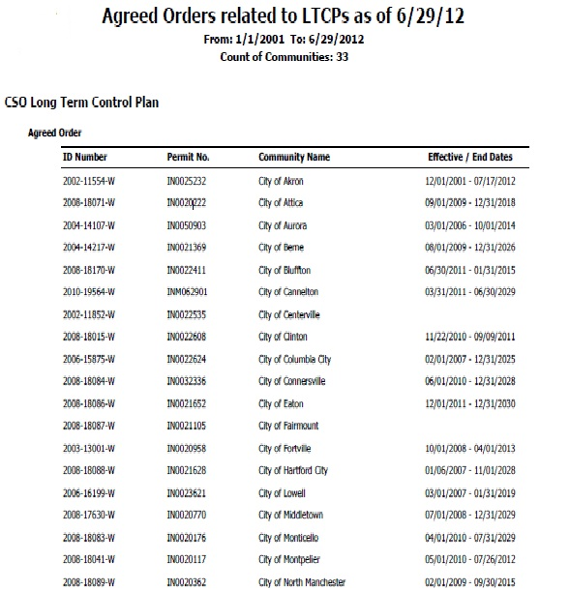

- Metrics Report: Generates a report which lists the total CSO communities, total approved LTCPs, total LTCPs remaining to be approved, and total LTCPs fully implemented.

Frequently, upper management is asked to provide status reports on CSO related topics. The Metrics Report provides information that is readily obtainable without the need to query staff.

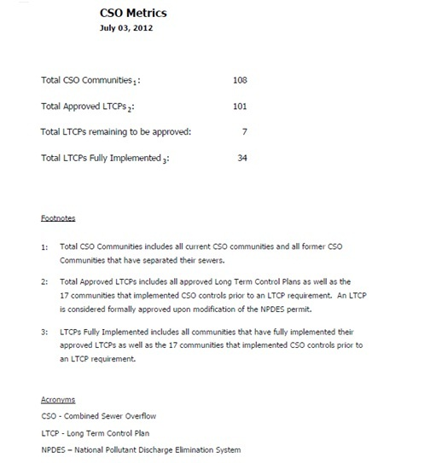

- Outfalls Report: Filters on this report can be set to provide a wide range of information regarding CSO outfalls. Based on the data logged in TEMPO (as indicated above), this report can generate location, waterbody information, active status, treatment status, etc. by community, county, receiving stream, or watershed. This report is particularly useful for public information requests.

The example report below shows all CSOs and related CSO statuses in Madison County.
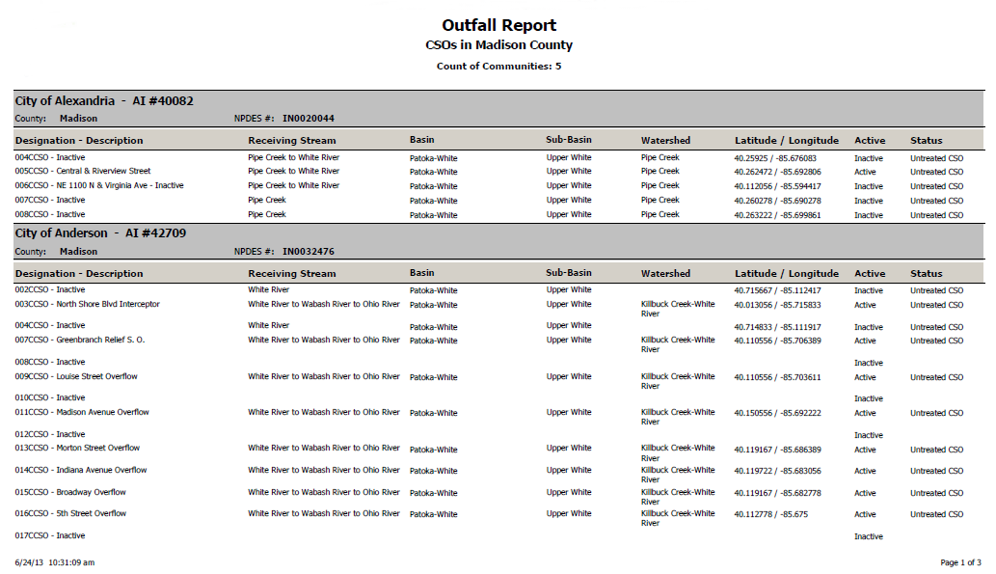

- WAL (Work Activity Log) Tasks Reports: This report is the most used for CSO program activities. The filters on this report provide a limitless range of information. For example, this report can provide overdue tasks for each community, can provide completed tasks for each community, can search a common task among all communities, can give “universe” of tasks for the whole CSO program, etc. This report is being used monthly to keep track of which communities may be behind in their LTCP implementation. This report also is used to track completion of internal tasks, such as audits and LOC reviews, for staff scheduling purposes. Another useful way to use the report is to search a specific type of project.

Below is a typical report generated at the end of each month by each project manager to determine which facilities are behind schedule.
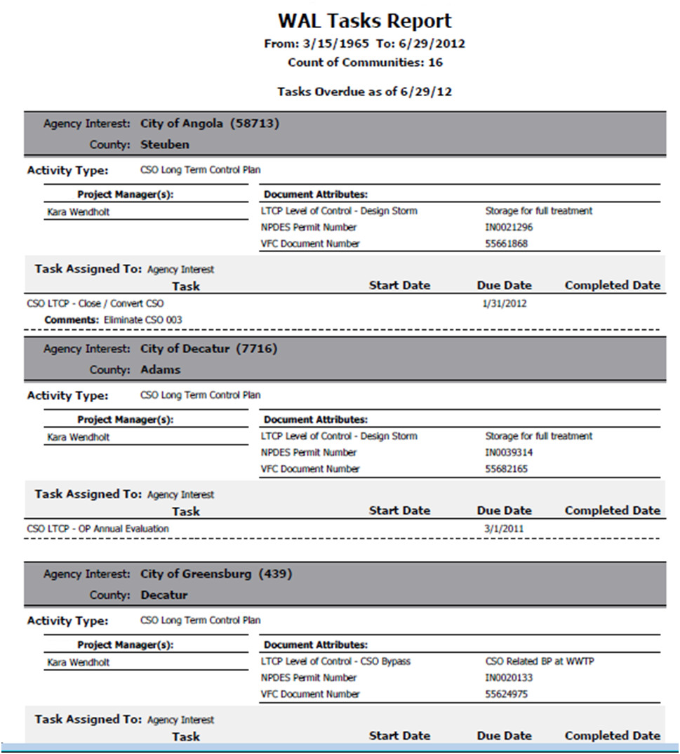

Possible Future Capabilities:

Various future enhancements to the IDEM CSO Tracking database are possible. The TEMPO software application is Oracle-based and can be interfaced with the EPA Integrated Compliance Information System (ICIS) system. This would enable future data exchange between TEMPO and ICIS.

Also, the outfall information in TEMPO contains geographic coordinates that allows integration with ArcGIS to display maps containing CSO related information. This part of the program is currently under development.

This example corresponds to the Outfall Report above, showing the CSOs in Madison County with their related status.
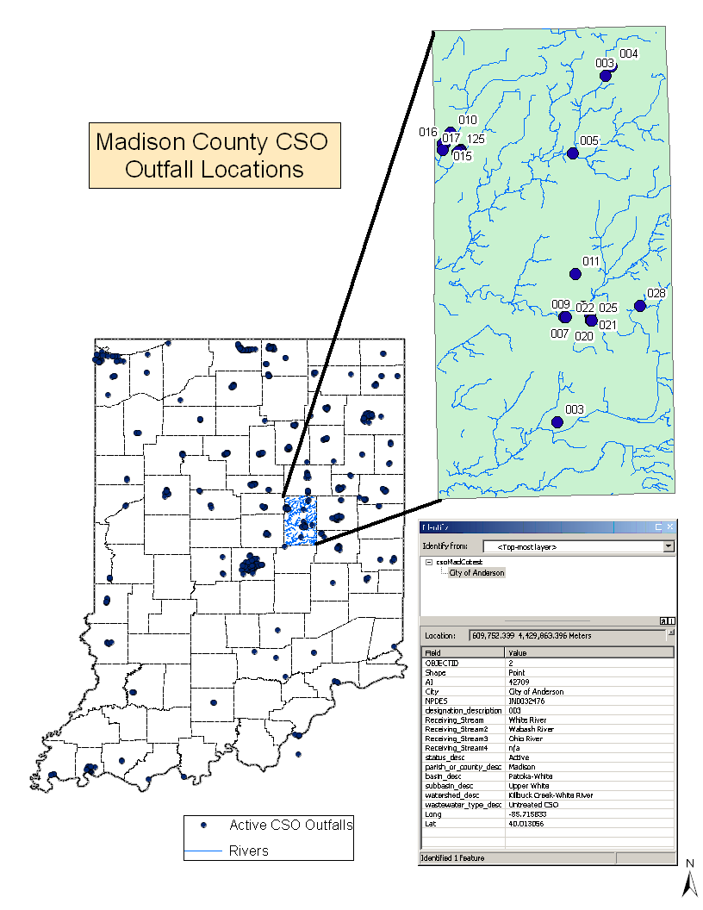

Contact:

Holly Zurcher
Indiana Department of Environmental Management
hzurcher@idem.in.gov
(317) 234-2122

PERMITTING INNOVATIONS

South Carolina’s Permit Central
Description of Initiative:
Many customers wonder which permits they will need to open or expand their business, as well as how long the process will take. The South Carolina Department of Health and Environmental Control (DHEC) now offers new customer service tools to aid the permitting journey.
Customers can see the full picture up front using the DHEC Permit Central website (http://www.scdhec.gov/PermitCentral). The website’s interactive questionnaire uses customer answers to determine which permits they will likely need. The questionnaire poses questions based on the customer’s business interest. Permit Central also includes timeframe estimates, tips for speeding the permitting process, application forms, and a database that allows customers to check the status of their application. It also links customers with the DHEC Permit Central Team. The multi-media Permit Central Team helps customers draw a reliable roadmap for their permitting processes. For citizens, the Permit Central website provides valuable information such as public notice opportunities or how to apply for permits to build your own pond.
Permit Central was tested with businesses, consultants, and economic development representatives before going live. The new tools were launched by the DHEC Director and South Carolina Governor at a press conference in March 2013. Customers can get online information on their own timetable and also meet with the Permit Team to receive tailored information specific to their business plans. These tools help make the environmental and health permitting processes as smooth as possible.
Results to Date:
Permit Central has served many customers since the March 2013 launch. Examples of Permit Central successes include the following:
- In three months, Permit Central has hosted 14 meetings and responded to 30 phone calls and 17 emails. Each response usually includes input from several DHEC employees, delivered in one comprehensive response.
- In three months, the Permit Central website has been viewed over 21,700 times.
- DHEC employees have expressed that Permit Central makes their job easier. The employee answers the direct customer question and then offers the Permit Central service for related, comprehensive media issues.
- Customer feedback to date includes:
"I appreciate how quickly you responded to my question. I wish all customer service was as responsive as you."
“I am writing today to thank you for the impressive and responsive meeting that was held today to help my company determine our path forward with exciting growth opportunities in the Charleston area and the Upstate.”
“I am extremely impressed with your team and the way they opened their doors for us today. Their ‘customer service’ attitude will go a long way in bringing new business to our great state of South Carolina.”
Contact:
Shelly Wilson
Federal Facilities Liaison
South Carolina Department of Health and Environmental Control
wilsonmd@dhec.sc.gov
(803) 898-3138

Pennsylvania’s Permit Review Process and Permit Decision Guarantee

Description of Initiative:

By signing Executive Order 2012-11 last July, Gov. Tom Corbett charged the Pennsylvania Department of Environmental Protection (DEP) with developing and implementing a policy that results in more timely permitting decisions, provides clear expectations for applicants to improve the quality of applications, establishes performance measures for DEP’s permit review staff, and implements electronic permitting tools to enhance internal operations.

To implement the directive of Executive Order 2012-11, DEP issued the “Policy for Implementing the [DEP] Permit Review Process and Permit Decision Guarantee” which:
- Established a standardized review process for permit applications;
- Provided certain and predictable review times for applicants who submit complete, technically adequate applications that address all regulatory and statutory requirements;
- Articulated clearly and concisely expectations for applicants that result in complete, technically adequate applications that address all regulatory and statutory requirements;
- Established expectations of DEP staff aimed at achieving greater efficiency, clarity, and consistency across regions and programs;
- Improved the DEP’s internal tracking and coordination of permit applications

To create a robust and effective policy, DEP conducted extensive outreach with members of the regulated community, local governments, and the public. In all, the department held 14 different webinars focusing on different types of permits, reaching more than 1,650 people.

Results to Date:

Just six months of implementation indicates success of the new policy as DEP is becoming more efficient in issuing protective and timely permits.

Increased Predictability (measured in the percentage of permits meeting target and/or guarantee):
- Permit Review Process – 97 percent
- Permit Decision Guarantee – 96 percent

Specifically, when compared to the previous permitting structure, the following increases in efficiency have been measured for those permits included in the Permit Decision Guarantee:

Improved Efficiency (measured in fewer average days to process):
- Mining—56 percent
- Oil and Gas—10 percent
- Waste, Air, Radiation and Remediation (WARR)—35 percent
- Water —45 percent

During this time, 11,096 permit applications were processed under the Permit Review Process, and 6,243 permit applications were processed under the Permit Decision Guarantee.

To learn more about the Permit Decision Guarantee and DEP's revised permitting process, visit www.depweb.state.pa.us and click on the Permit Decision Guarantee link.

Contact:

Hayley L. Book
Policy Director
Pennsylvania Department of Environmental Protection
hbook@pa.gov
(717) 772-3612

WASTE INNOVATIONS

Wisconsin’s Initiative for Sustainable Remediation and Redevelopment

Description of Initiative:

Building upon the Wisconsin Department of Natural Resources (WDNR) Remediation and Redevelopment Program’s history of applying innovation to a strong foundation of protecting public health and the environment as well as promoting economic vitality, the Wisconsin Initiative for Sustainable Remediation & Redevelopment (WISRR) Team was created. This team, led by a dedicated Sustainability Team Leader, meets monthly and is charged with promoting environmentally and socioeconomically responsible practices.

Since its inception in 2009, WISRR has changed the way cleanup sites are viewed by promoting the applicability of sustainable technologies in site remediation and encouraging the use of green concepts throughout the various stages of site cleanup and redevelopment. Saving energy, reducing greenhouse gases, and minimizing waste through reuse and recycling are all aspects of WISRR.

To assist WISRR in meeting its charge, the team created the Green and Sustainable Remediation Manual. The manual provides a framework for project managers, consultants, responsible parties, and others to incorporate green and sustainable concepts into the cleanup of contaminated sites.

Results to Date:

- In 2010, The WISRR Team’s showcase project became reality with the installation of 44 solar panels on a former 23-acre Superfund site in Middleton, WI (called Refuse Hideaway Landfill). The solar array, which is capable of generating 12,000 kilowatt hours per year, is offsetting 46% of the energy used to power the remediation systems. If this trend continues, the DNR’s return of investment will be 23 years, which is 7 years earlier than initial 30 year projections. Project results have served as a national model that EPA shares with other states promoting renewable energy on contaminated lands.
- Green and Sustainable Remediation requirements have been incorporated into revised state cleanup rules that were expected to be published in late 2013.
- As mentioned above, the WISRR Team created the Green and Sustainable Remediation Manual: A Practical Guide to Green and Sustainable Remediation in the State of Wisconsin, to help stakeholders evaluate and implement green and sustainable remediation practices during site cleanup.
- In the spring of 2012 the WISRR Team and EPA Greener Cleanups staff trained DNR staff on the use of the GSR manual and other green and sustainable practices. The team plans to host external training once the state cleanup rule revisions are published.
- The WISRR Teams Site Specific Sustainability Analyses document evaluates potential Green and Sustainable Remediation practices at four Wisconsin sites and provides recommendations that could be incorporated at other sites throughout the country.
- The WISRR Team created the following quick reference guides to provide specific off- the-shelf examples of Green and Sustainable practices:
- Greener Remediation Optimization Techniques
- Greener Site Investigation Techniques
The guides have been extremely helpful during Project Manager and Responsible Party discussions.
- Participation in External Workgroups: WISRR Team members share lessons learned and Best Management Practices with a variety of workgroups in which they are active members:
  - Sustainable Remediation Forum (SURF)
  - ASTM Greener Cleanups Workgroup
  - EPA/States Region 5 Greener Cleanup Workgroup

For more information, please visit http://dnr.wi.gov/topic/brownfields/rrprogram.html (Greener Cleanups tab).

Contact:

Tom Coogan
WISRR Team Leader
Thomas.Coogan@wi.gov
(608) 267-7560

Massachusetts’ Diversion of Organic Material from Disposal to Clean Energy and Other Beneficial Uses

Description of Initiative:

Massachusetts is implementing a nation-leading program to convert a solid waste problem into a clean energy solution. Through a combination of regulatory mandates, financial assistance, and the state leading by example, Massachusetts is poised to divert 450,000 tons/year of organic waste that would otherwise be burned in incinerators or buried in landfills. Instead, this material will go to composting facilities, or even better to anaerobic digestion facilities which create a clean biogas that can be used for electricity and heat. This initiative will lower greenhouse gases, boost the state’s renewable energy production, and create jobs in a new sustainable industry.

Massachusetts’ Solid Waste Master Plan sets a goal to quadruple the diversion of organic material from disposal in landfills and incinerators from the current level (100,000 tons per year diverted) to 450,000 tons per year by 2020. Once diverted from the trash, much of this organic material will go to anaerobic digesters, an emerging technology that generates renewable biogas and creates beneficial byproducts (for animal bedding, compost, and fertilizer) while reducing the potential of nuisance odors. The Commonwealth also has a goal to have three anaerobic digestion facilities on state land and multiple private facilities either operating in active permitting in 2014, and to increase energy production from aerobic and anaerobic digestion to 50 megawatts (375 GWh/y) by 2020. To achieve these goals, the Massachusetts Department of Environmental Protection (MassDEP) has developed and is implementing a multi-pronged strategic Organics Action Plan.

The Organics Action Plan includes initiatives that are collecting and analyzing data, building a robust and efficient collection and diversion infrastructure, establishing increased processing capacity and markets, and improving the Commonwealth’s regulatory framework for managing organic materials that have been diverted from waste and for harvesting clean power and other beneficial uses from this material. Key components of this effort include: established regulations designed to foster safe siting of facilities that beneficially reuse source-separated organics including anaerobic digestion; proposing a ban on disposal of organic material in waste by large commercial generators that will preserve dwindling landfill capacity as well as create a valuable feedstock for anaerobic digestion; proactively siting three anaerobic digestion (AD) facilities on state lands (including using food waste generated at a university and two prisons to create lower-cost clean energy that can be used onsite); providing technical and financial assistance for waste management and diversion to large commercial generators of organic waste; and making low-interest loan funds available to construct AD operations, building a strong market for this technology in Massachusetts.

A central component of this strategy is the proposed waste ban, which would apply to any business or institution that disposes more than one ton of organic material per week. MassDEP expects this ban to increase recycling by 350,000 tons of organic waste each year, capturing valuable materials for renewable energy generation and soil enrichment, generating jobs and economic development in Massachusetts, and supporting improved materials management at farms and wastewater treatment plants. A draft waste ban regulation was out for public comment as of mid-2013, and MassDEP has proposed to have the ban take effect in summer 2014.

Results to Date:

- Revised solid waste regulations for safely siting organics processing facilities have been promulgated (2012)
- 100,000 tons per year of organic material is currently being diverted from disposal to beneficial uses
- More than 300 supermarkets have established food waste diversion programs
- Two farm-based AD facilities are operating, and proponents are developing plans for 10-12 additional facilities
- Identified three sites on state land to be suitable for new AD facilities, and completed feasibility studies for two of the three, and planned to issue a request for proposals seeking private developers to run these
- An increased number of haulers are offering organics collection services to generators
- Nearly 30 compost sites are currently approved to take commercial-scale food waste
- Developed robust data on commercial food waste generation and management
- Created the “RecyclingWorks in Massachusetts” program to provide information and direct technical assistance to businesses and institutions
- Established broad support for the proposed ban and developed guidance and assistance materials to help businesses comply, including more than a dozen case studies on successful programs

Actions Completed and Ongoing:

- Issued draft waste ban regulations in July 2013; to be effective July 2014
- Providing more than $6 million in funding to support the growth of AD (in concert with the Massachusetts Department of Energy Resources and Massachusetts Clean Energy Center)
- Providing municipal grants to support the growth of food waste composting and municipal collection systems
- Developing guidance for local health officials on managing food waste collection

Contact:

John Fischer
Business Recycling Branch Chief, Bureau of Waste Prevention
Massachusetts Department of Environmental Protection (MassDEP)
John.Fischer@state.ma.us
(617) 292-5632

WATER INNOVATIONS

Iowa’s Point Source Nutrient Reduction Strategy

Description of Initiative:

The Iowa Nutrient Reduction Strategy is a pragmatic approach for reducing nutrient discharges from the state’s largest wastewater treatment plants together with targeted best management practices designed to reduce contributions from nonpoint sources.

The point source portion of the nutrient reduction strategy established a process to achieve significant reductions in the amounts of nitrogen and phosphorus discharged to Iowa’s rivers and streams by the largest industrial and municipal wastewater treatment plants. Major point sources will be required to assess the feasibility and reasonableness of reducing the amounts of nitrogen and phosphorus discharged to Iowa surface waters. Practices determined to be feasible and affordable will be required to be implemented.

A total of 102 major municipal facilities serve the wastewater treatment needs of 55-60 percent of Iowa’s population and treat more than 80 percent of the volume of all wastewater handled by Iowa cities. Twenty-nine major and seventeen minor industries also have the potential to discharge significant amounts of nitrogen and phosphorus into Iowa waters.

For the first time, discharge permits issued to these 148 facilities will require implementation of technically and economically feasible process changes, primarily additional biological treatment to remove nutrients. These changes are designed to achieve at least a two-thirds reduction in the amount of nitrogen and a three-fourths reduction in the amount of phosphorus from levels currently discharged by these facilities.

The process is unique and innovative. In the traditional approach limits are established in a permit and treatment facilities are constructed to meet those limits. In this approach, nutrient reduction facilities are constructed, sampling is performed and technology-based limits are developed using actual treatment plant performance data.

This strategy has the potential to reduce by at least 11,000 tons per year the amount of nitrogen and 2,170 tons per year the amount of phosphorus discharged by municipal facilities alone. These figures represent a 4% reduction in nitrogen and a 16% reduction in phosphorus from the estimated statewide amounts of nitrogen and phosphorus entering Iowa waters from both point and nonpoint sources.

This approach is estimated to have a total present worth cost (includes capital costs and operation and maintenance cost over a 20-year period) of approximately $1.5 billion with an annual cost of $114 million.

Results to Date:

Iowa’s Nutrient Reduction Strategy was recently finalized in May 2013 after nearly two years of development. National Pollutant Discharge Elimination System permits are already being developed with requirements to implement the strategy. Several treatment plants that were already under construction while the strategy was being developed voluntarily included nutrient removal processes in their design.

Contact:

Adam Schnieders
NPDES Program Supervisor
Iowa Department of Natural Resources
adam.schnieders@dnr.iowa.gov
(515) 281-7409

Virginia’s Wetland Condition Assessment Tool

Description of Initiative:
Virginia’s Department of Environmental Quality (DEQ) Office of Wetland and Stream Protection, in collaboration with the Virginia Institute of Marine Science, has developed a wetland monitoring and assessment protocol to provide an ongoing assessment of the status of the Commonwealth’s wetland resources and the success of both wetland regulatory and voluntary programs.
The assessment protocol consists of a three-tiered approach using comprehensive coverage of all mapped non-tidal wetlands to achieve a GIS based analysis of remotely sensed information (Level I). Level I scores wetland types based on the habitat and water quality stressors associated with surrounding land use types. Levels II and III are intended to calibrate and validate the model that is used for Level I analysis. By having a statistically validated tool that measures wetland quality as a function of habitat and water quality parameters, DEQ permit staff will be able to make better permit decisions. Further, DEQ will be able to measure how well we are protecting the function of our more vulnerable wetlands (i.e., isolated wetlands), by comparing the condition of wetland habitat and water quality parameters as a function of the assessment scoring over time.
Results to Date:
The data collected from the assessment have been compiled into an online GIS-based wetland data viewer identified as the Wetland Condition Assessment Tool (WetCAT). One unique aspect of WetCAT is its online interactive user interface, which allows users to overlay data such as previously permitted impacts and impaired waters and run various geoprocessing tools to visualize cumulative impacts, downstream flow, and upgradient drainage areas.
The goal of WetCAT is to support DEQ’s regulatory decision-making, allow reporting of wetland condition, and provide information for policy development. In particular, information derived from monitoring will be used to:
- Report ambient wetland conditions in Virginia's Clean Water Act Integrated 305(b)/303(d) report;
- Evaluate wetland impacts from proposed projects within a watershed context during permit review as part of Virginia's regulatory program;
- Evaluate the performance of wetland restoration and other compensatory wetland mitigation in replacing wetland acreage and function, including changes in wetland condition over time based upon surrounding landscape changes and maturity of the mitigation site; and
- Evaluate the cumulative impacts of wetland loss and restoration in watersheds relative to ambient ecological conditions and water quality management needs.

One of the advantages of the Virginia protocol is a comprehensive assessment of secondary impacts to wetland resources arising from activities that do not directly impact wetlands. This information can guide policy discussions on general land use management, stormwater, and land use planning. Linking decisions in these areas to wetland policy will be essential to achieving our statutory requirement of no net loss of wetland acreage and function, and aid local governments with planning tools at a watershed level.
Additional data sets and GIS layers will allow Virginia to continue to develop a wetland data viewer for use by regulatory agencies and the general public. Our success will be measured by an increasing trend in the statistically-reliable Level I protocol and a decreasing trend in cumulative wetland impacts over time.

Contacts:

David L. Davis, CPWD, PWS
Director, Office of Wetlands & Stream Protection
dave.davis@deq.virginia.gov
(804) 698-4105

Michelle M. Henicheck, PWS
Senior Wetland Ecologist
michelle.henicheck@deq.virginia.gov
(804) 698-4007

The report is available online here: http://www.oregon.gov/DEQ/AQ/Pages/Greenhouse-Gas-Inventory-Report.aspx

